Tan Dao

CSE 445

Professor: Yinong Chen

Pucture of localhost index

Pucture of XML and XSD on general

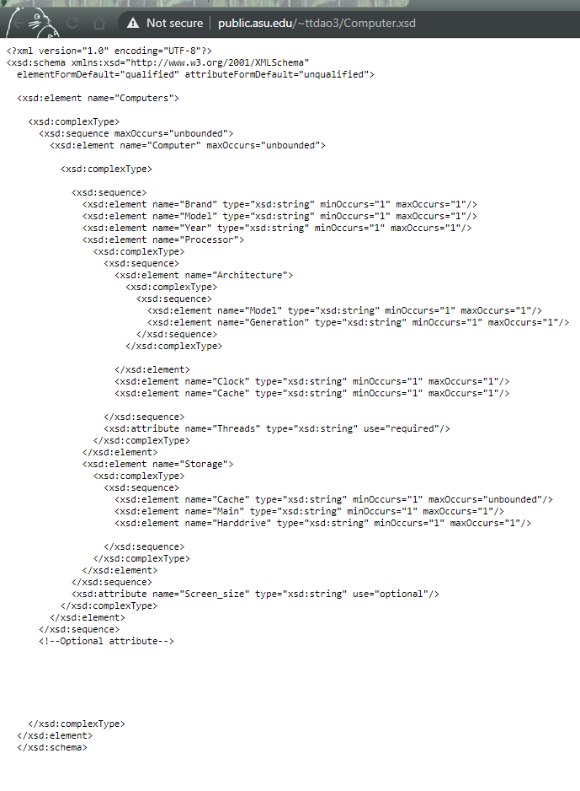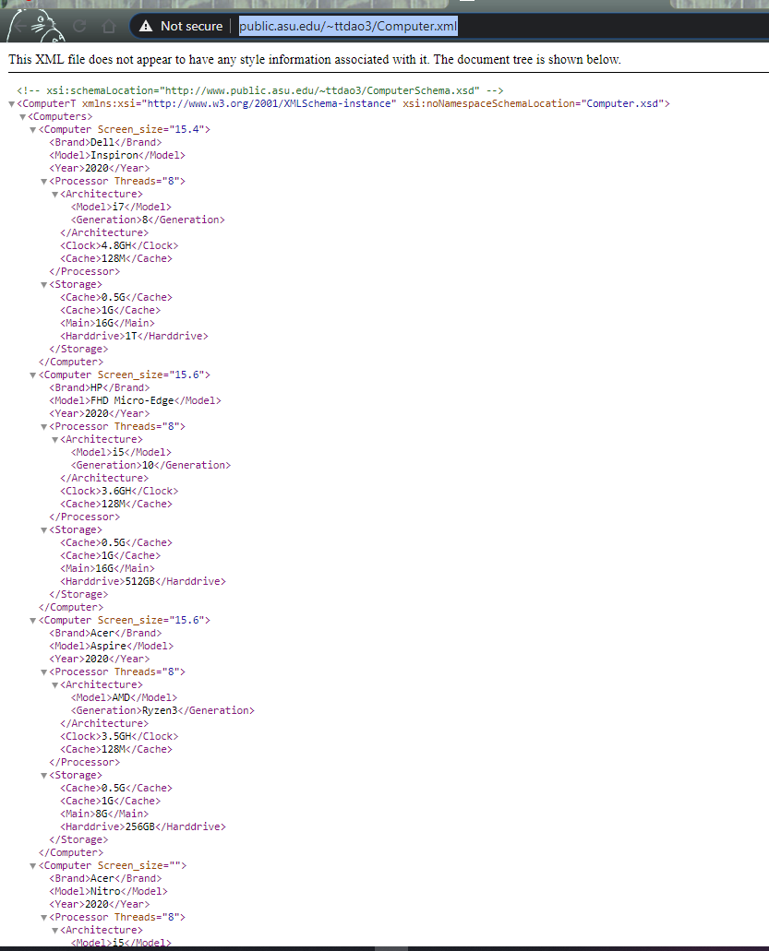XML: XSD:

Validation Service :

NoError

Error Example:

1)

2)

Add Computer Service:

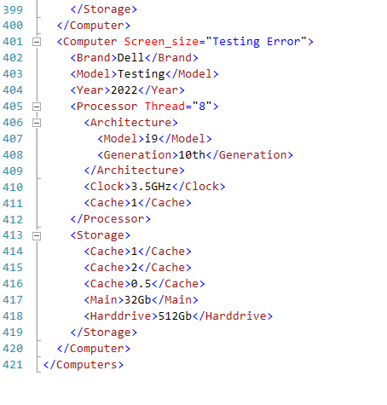

Add Computer Error :

